

**Nystagmus Eye Tracking**



|  |  |
| --- | --- |
| Name | ID |
| Shehab Mohamed Ibrahim | **9202720** |
| Mohamed Aziz Hammam | **9221153** |
| Salema Abdeltawab | **9210463** |
| Mahmoud Emad | **9190272** |
| Basmala Tarek | **9213125** |

# Supervised by Dr. Aliaa Rehan

**Introduction and Problem Statement**

Nystagmus, a neurological disorder characterized by involuntary, rhythmic eye oscillations, significantly impairs visual acuity, spatial orientation, and quality of life. Current diagnostic methods, such as electro-oculography or clinician-based assessments, are cost-prohibitive and may have limited accessibility in low-resource regions. Treatments like medications or surgery exhibit variable efficacy, while clinic-bound biofeedback lacks scalability. This underscores the critical need for an integrated, objective, and portable solution to enable real-time quantification of nystagmus parameters and offer adaptive, home-based rehabilitation.

**Proposed Solution**

Our solution merges two modules: (1) smartphone-compatible eye-tracking for real-time assessment and (2) Unity-based gamified training with machine learning (ML)-driven personalization.

**Assessment: Objective Quantification of Eye Movements**

The assessment phase employs a train simulation game where patients track a dynamic red circle (target) moving horizontally across a train’s front cabin. The process involves (figs 1&2):

1. Video Capture & Preprocessing: OpenCV captures real-time frames, converting colors and enhancing visibility for accurate analysis.
2. Eye Detection & Landmark Extraction: MediaPipe Face Mesh detects 468 facial landmarks, focusing on pupil position and eyelid movements.
3. Measurement: Displacement, velocity, frequency, and amplitude of iris to evaluate nystagmus severity are calculated using geometric transformations.
4. Data Logging: Metrics are stored in Excel via Pandas for longitudinal tracking and clinician review.

A Long Short-Term Memory (LSTM) model analyzes gaze trajectories to classify severity (mild/moderate/severe), replacing costly hardware with smartphone cameras. Clinicians access dashboards to review patient's progress and performance.

**Training: Adaptive Gamified Rehabilitation**  
Post-assessment, patients engage in personalized exercises within the same Unity environment. The train simulation adapts dynamically:

* **Velocity Modulation**: Train speed increases as gaze accuracy improves.
* **Target Complexity**: Smaller targets or distracting backgrounds (e.g., flashing lights) challenge fixation stability.

A reinforcement learning algorithm adjusts parameters weekly, ensuring exercises remain challenging yet achievable. Clinicians remotely set safety thresholds (e.g., max speed) to prevent overexertion. Performance metrics, such as latency reduction and error rates, are shared via patient dashboards to enhance motivation.

**Figure 1: Process Diagram**

**Integration and Patient-Centric Validation**  
The system’s closed-loop design ensures assessment data informs initial training parameters, while real-time metrics refine difficulty. Two pilot patients completed online sessions, reporting the game’s simplicity and incremental challenges eased adherence. One noted, “The train theme made exercises intuitive, not clinical.” Feedback highlighted the need for customizable reward intervals, now integrated as adjustable settings.

Collaboration with neurologists ensured clinical relevance. Market research identified existing solutions, such as Tobii’s hardware-based eye trackers and VR/AR platforms like Vivid Vision, which rely on costly devices. In contrast, our smartphone-compatible system eliminates specialized hardware, enhancing accessibility for underserved populations.

**Conclusion**  
This solution bridges diagnostics and therapy through smartphone-compatible eye-tracking and adaptive gamification, reducing costs compared to clinic-based systems. Future work will expand exercise variety (e.g., object interception) and integrate telehealth for real-time clinician input. Continuous clinical aim to scale accessibility, particularly in underserved regions.

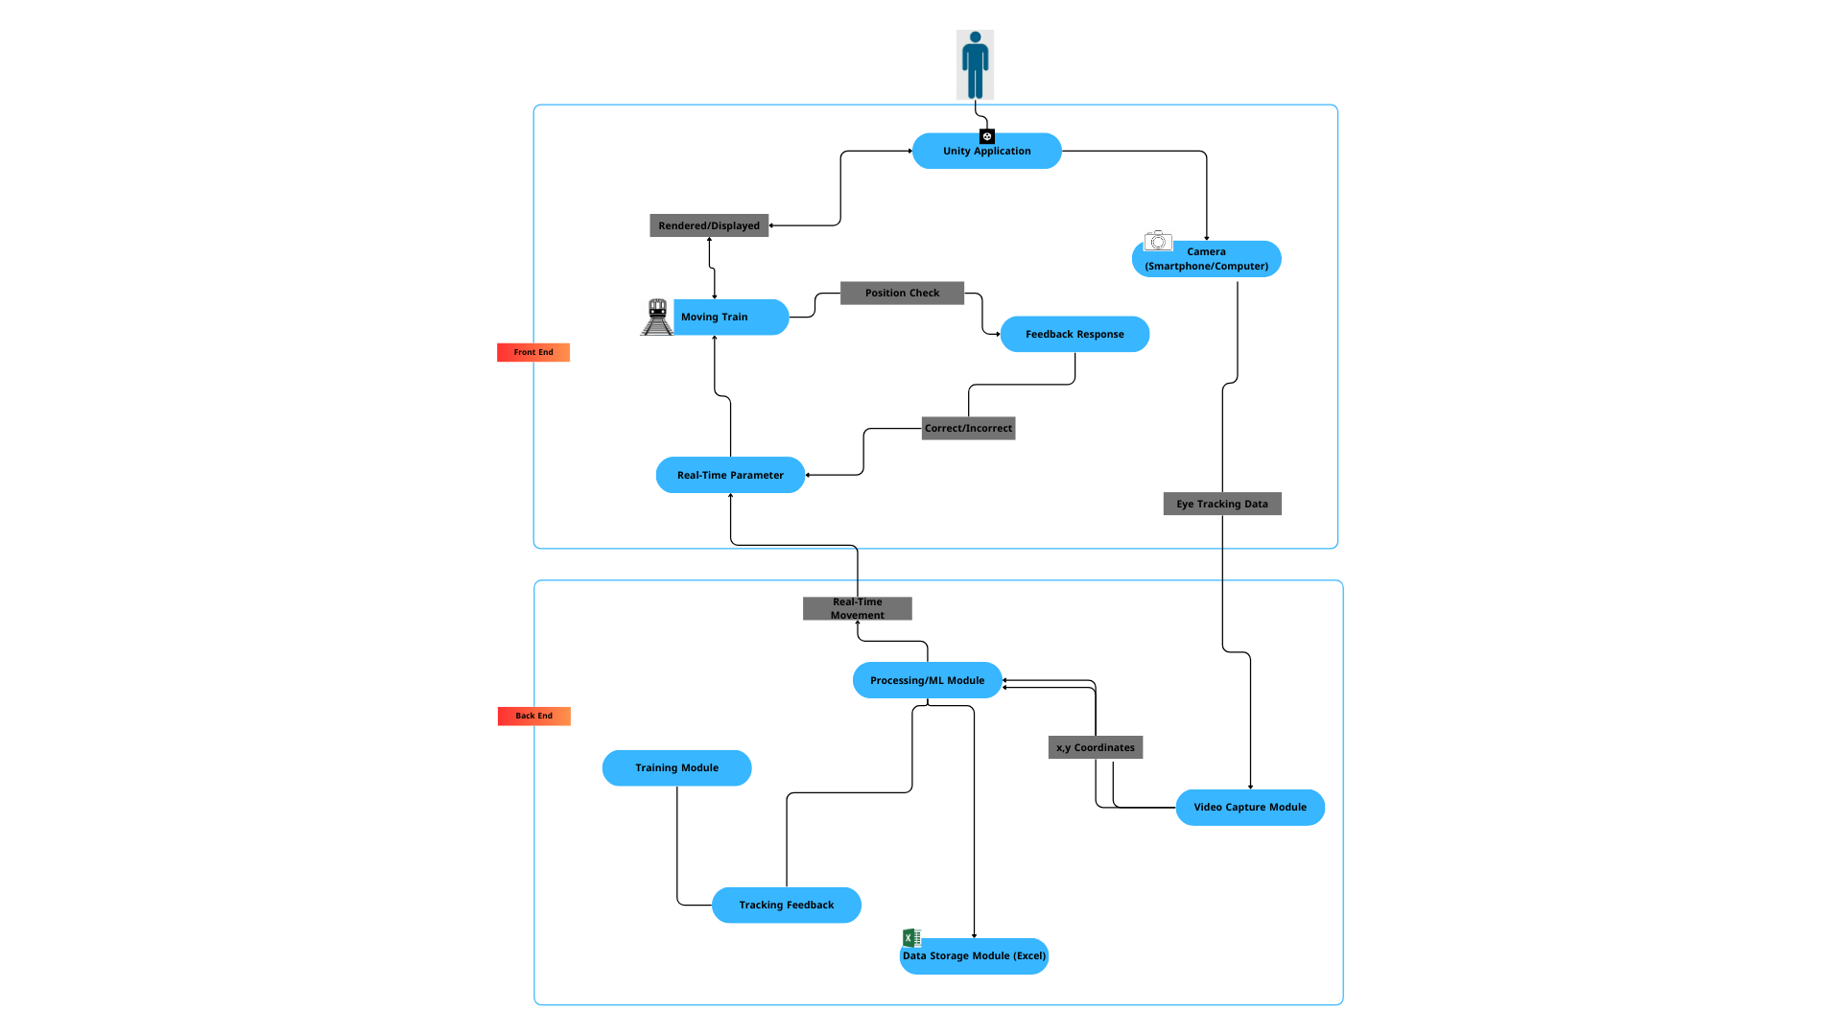

**Figure 2: System Architecture Diagram**